|  |  |  |  |  |  |
| --- | --- | --- | --- | --- | --- |
| Date | 25-Nov-22 | | | Tester Name | Mayuri Patel |
| Environment | Penfax - Test | | | Login used |  |
| Operating System | Select OS | Version: | Update: | | |
| Software Used | Select Software | Version: | Update: | | |
| Select Software | Version: | Update: | | |
| Release version | 22.4.1 | | | | |
| Title |  | | | | |
| Test Type | Regression | | | | |
| Test Scenario | Process a non-resident payment for USA | | | | |
|  |  | | | | |
| Expected Results |  | | | | |
| Pass/Fail | Pass | | | JIRA# | N/A |

Describe your steps with screenshots:

Search a MEPP member whose address is of USA and member status Terminated

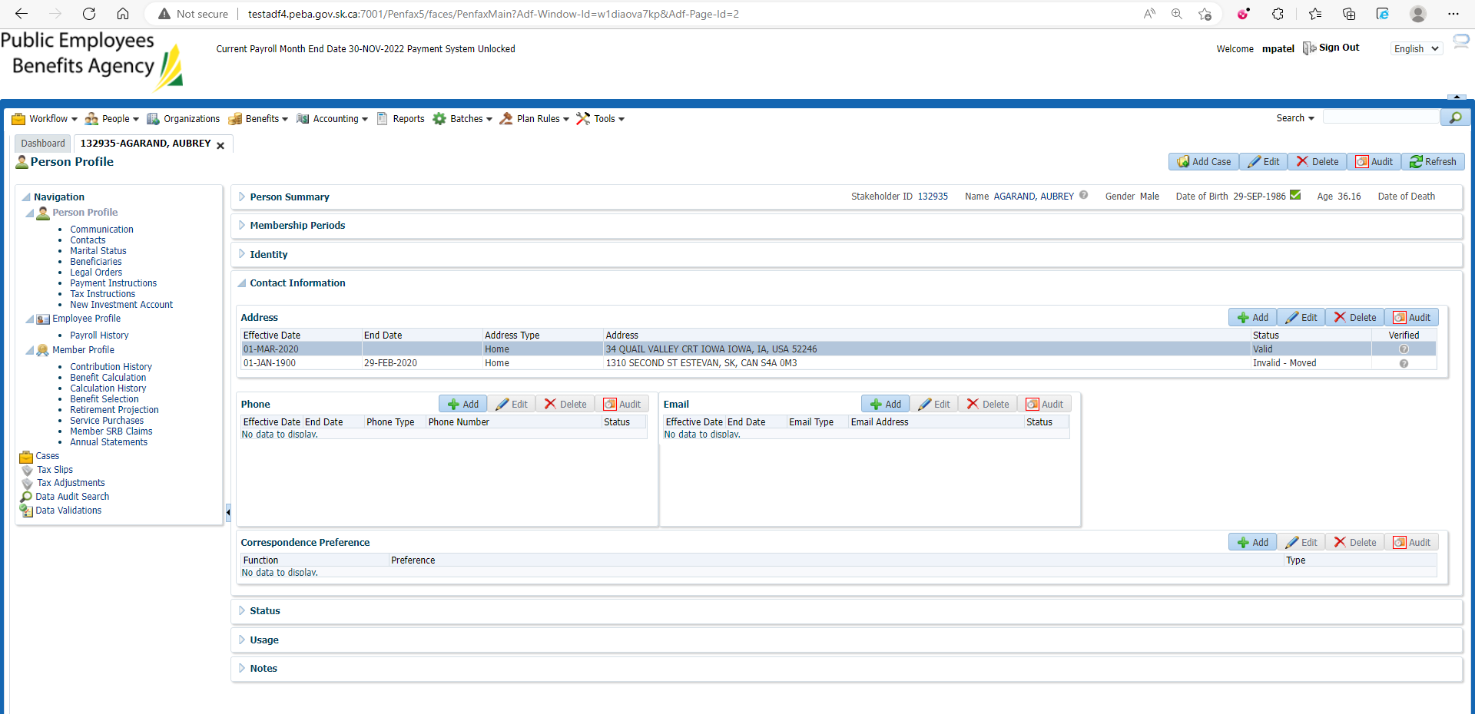

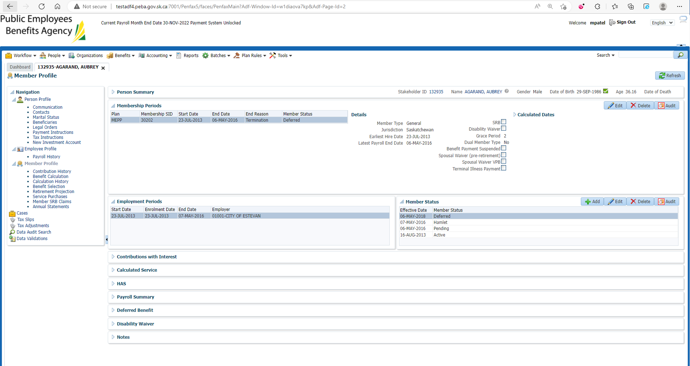

Go to Tax Instruction under Person Profile

Add Tax Instruction for country-USA

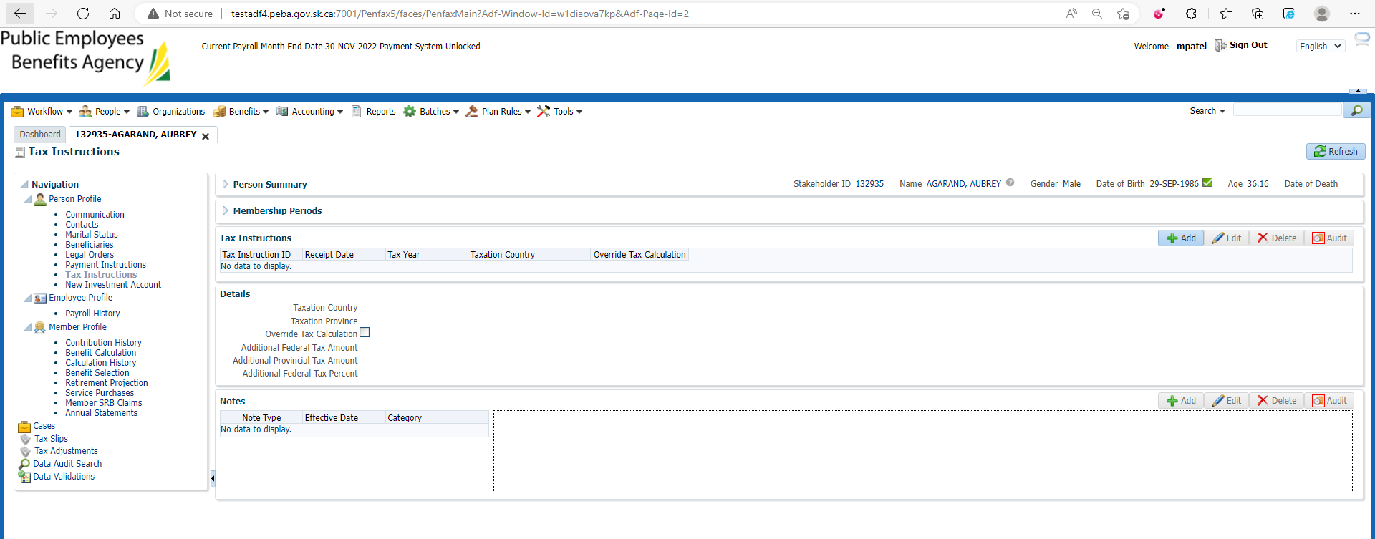

Save

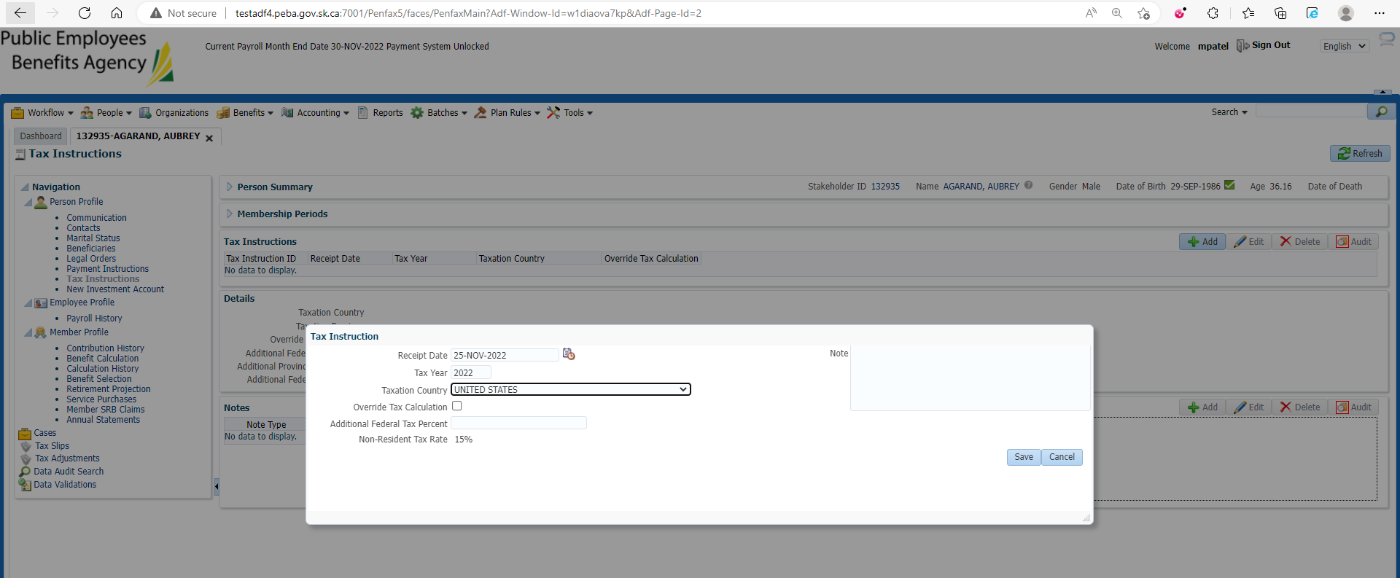

Tax Instruction is saved and reflected

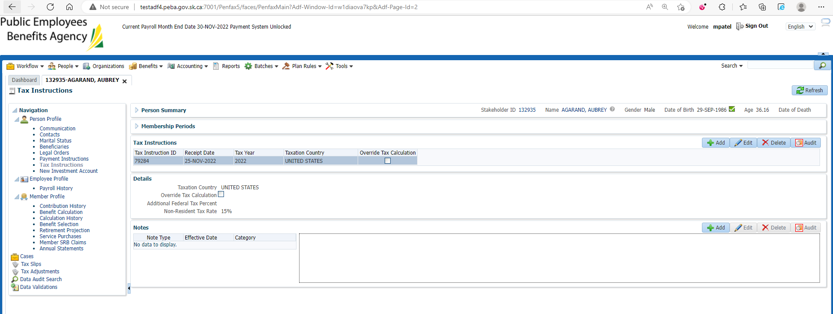

Go to Payment instruction under Person Profile

Add Payment instruction

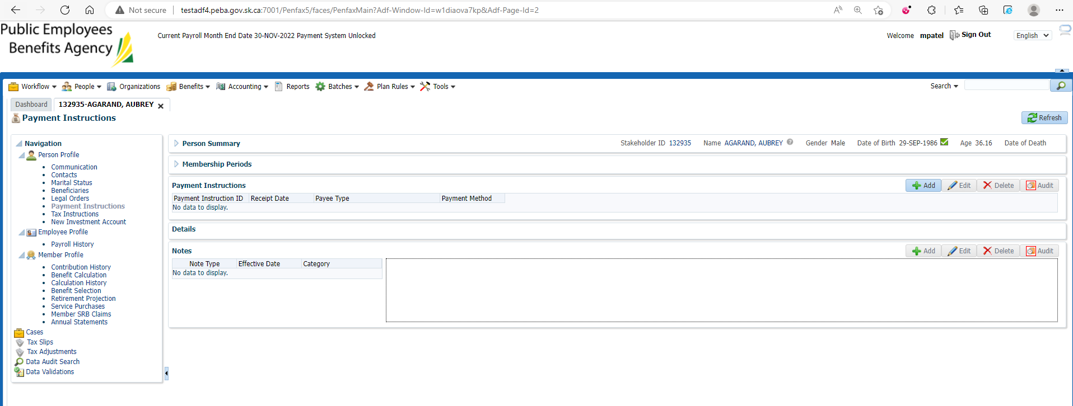

Payment Instruction is added and reflected

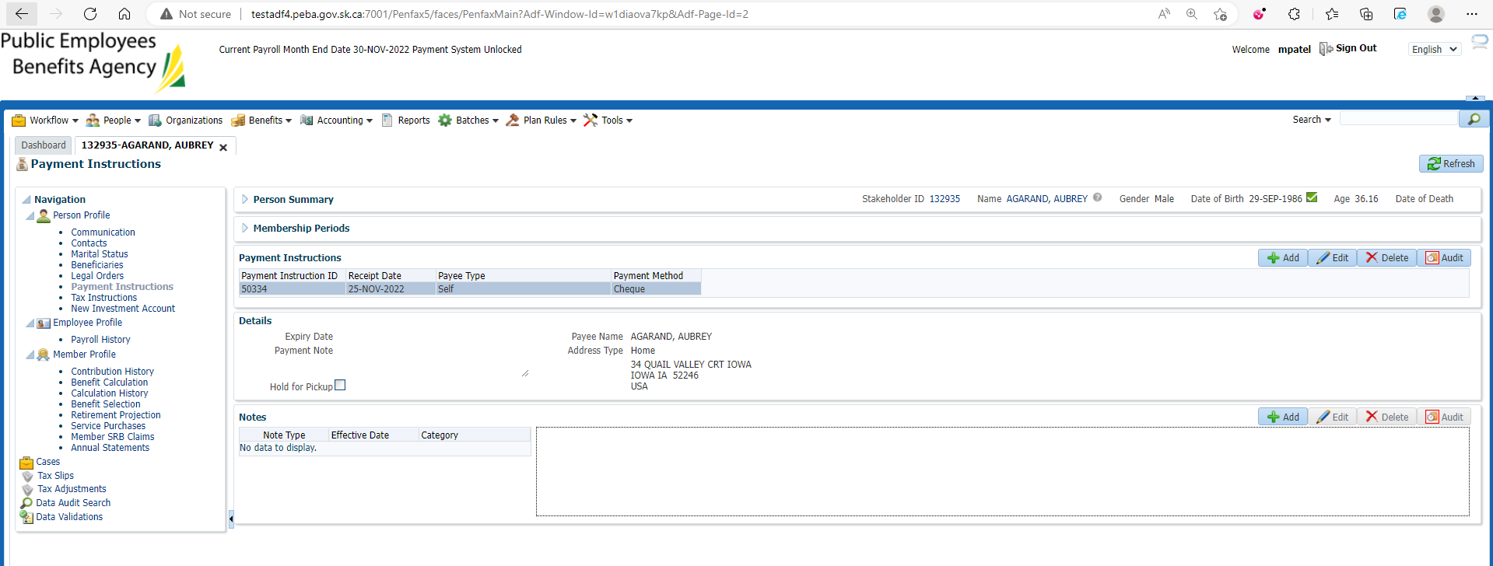

Benefit selection and Next

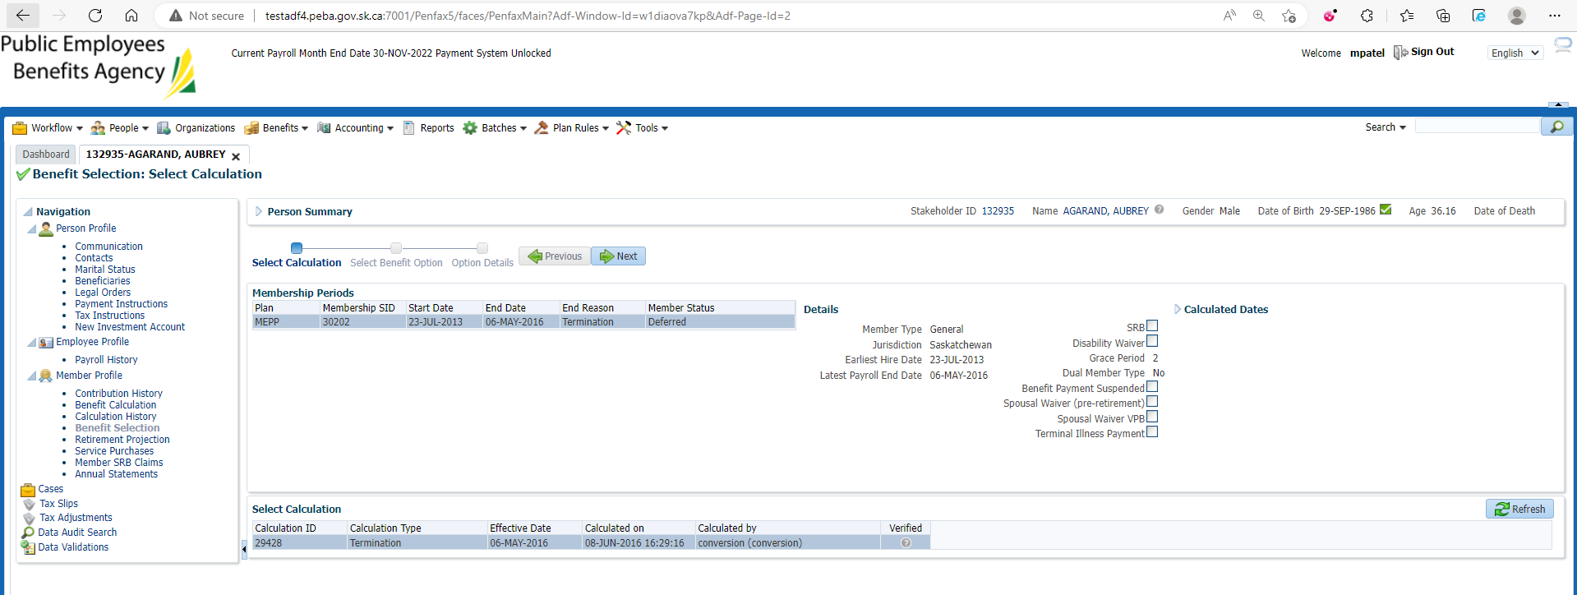

Enter Payment date and Next

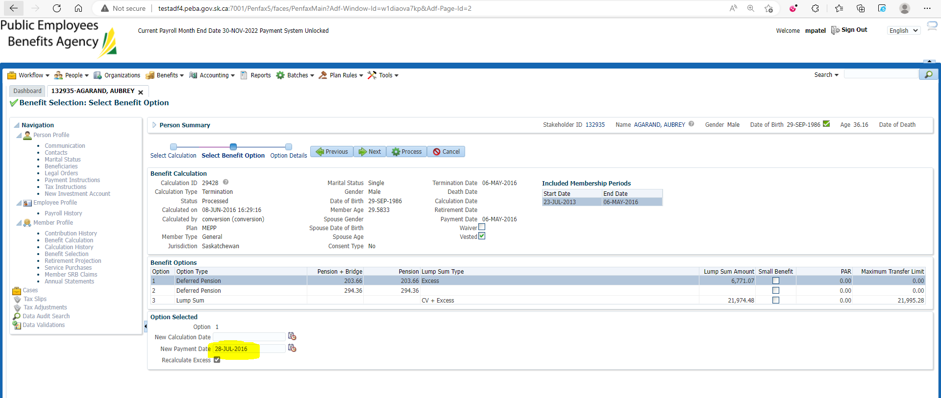

Process

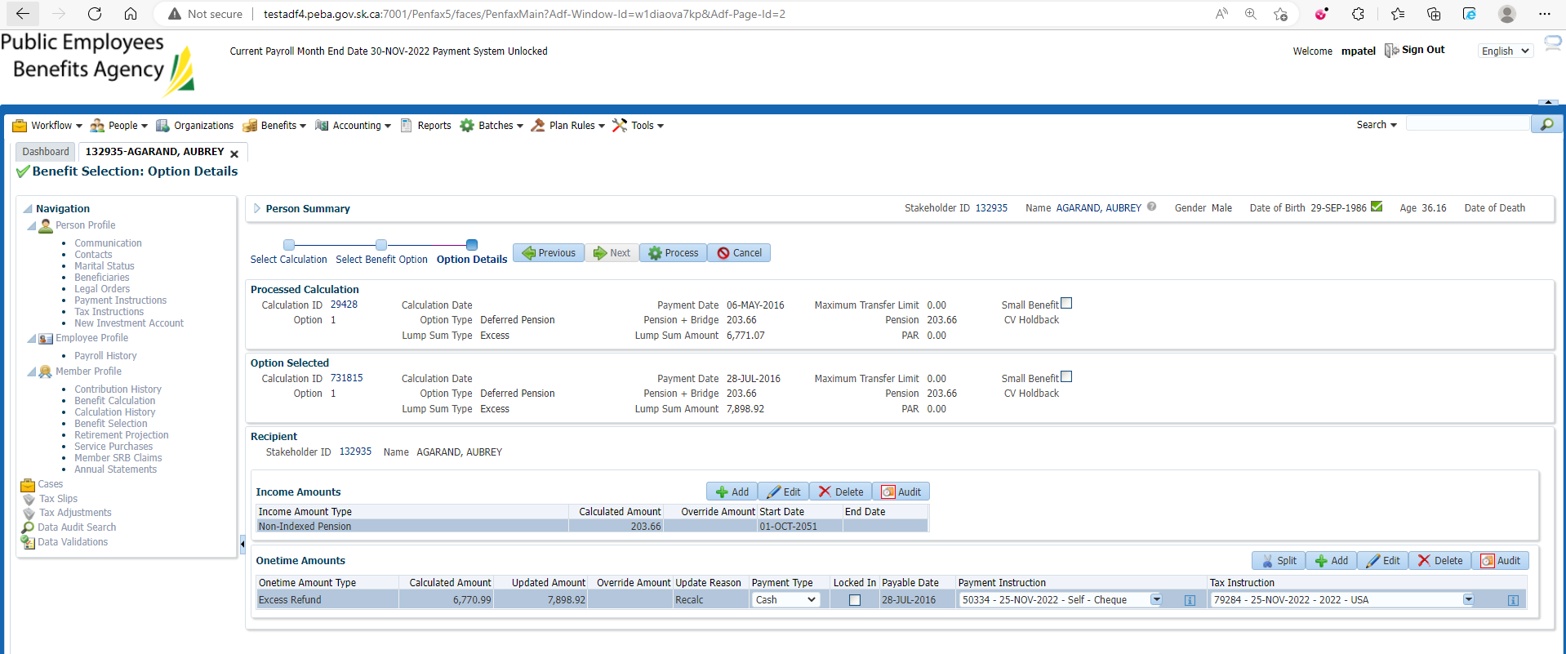

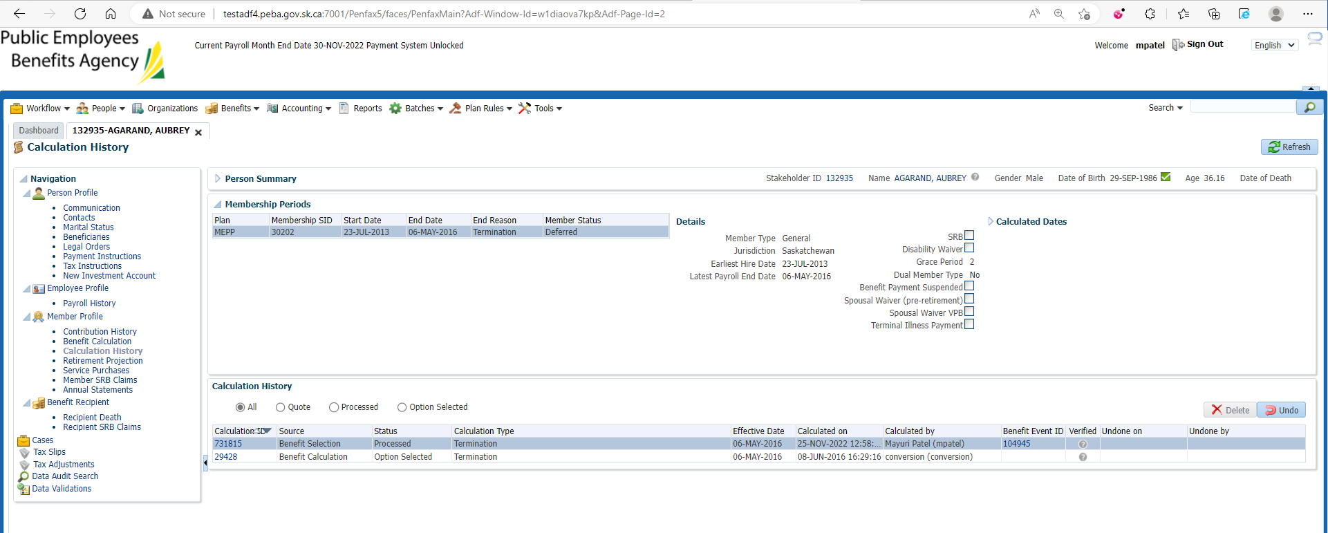

Under Benefit Recipient

Submit for Approval and Approve it

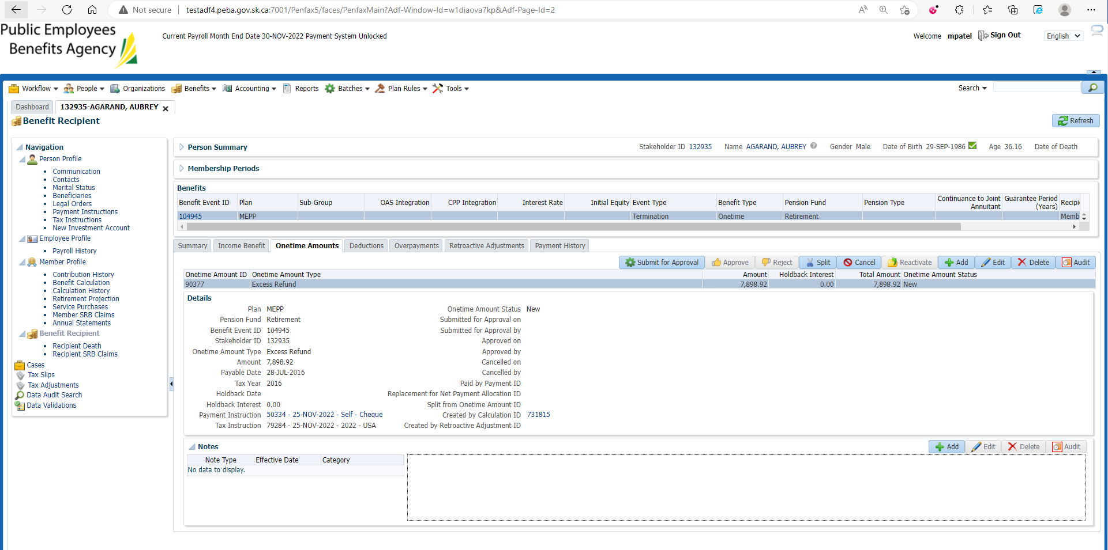

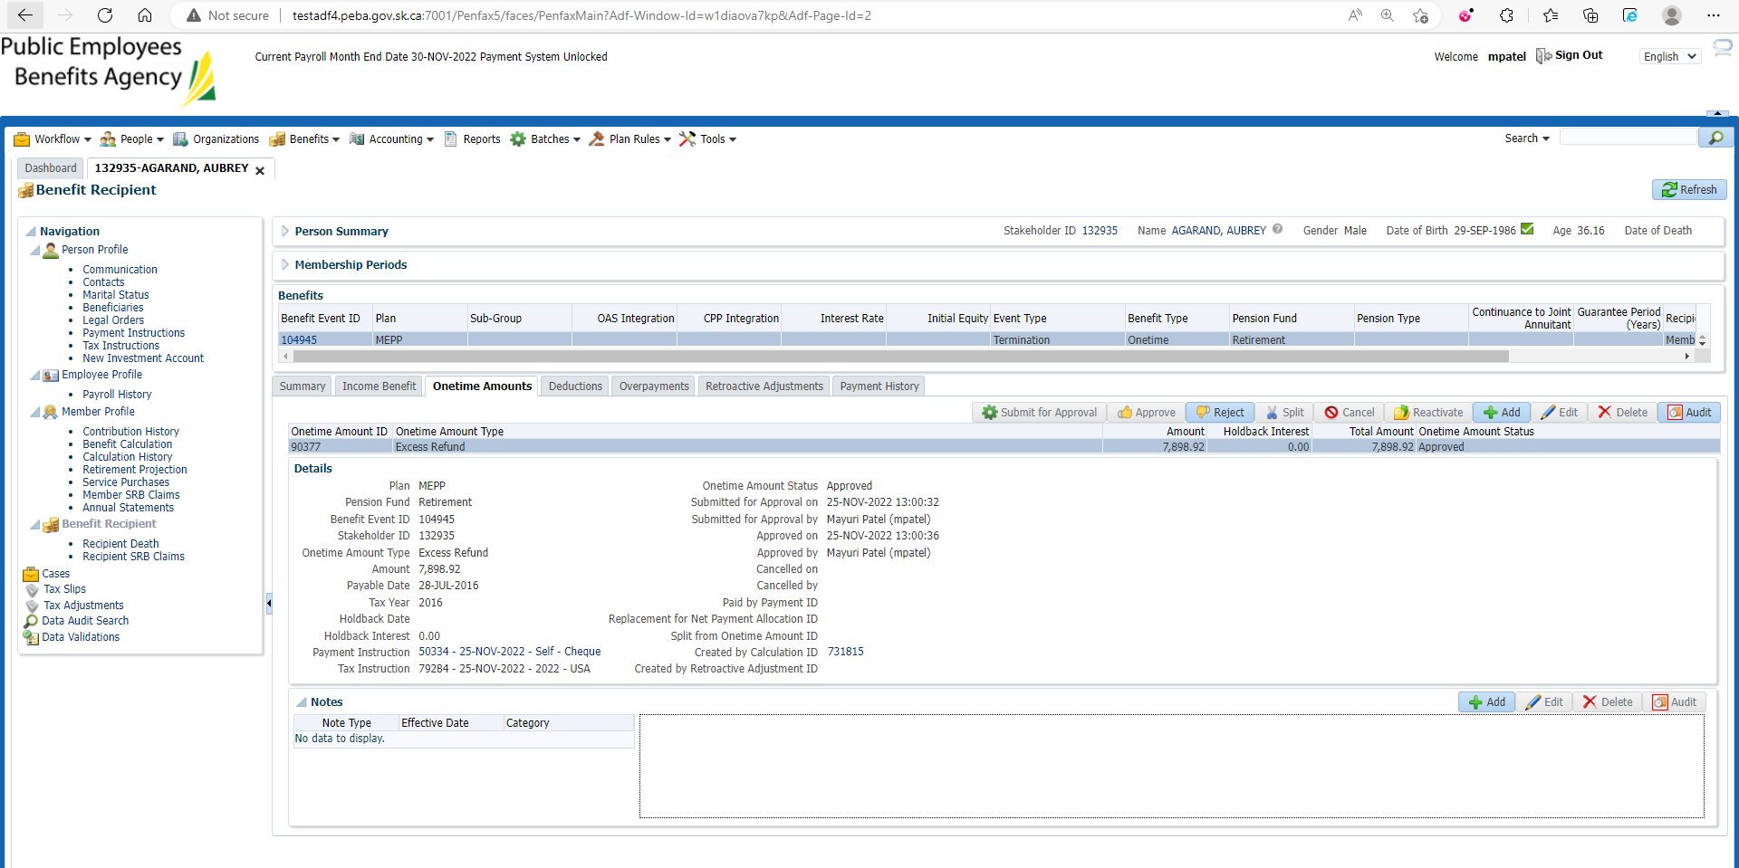

Under Summary tab Authorize the payment

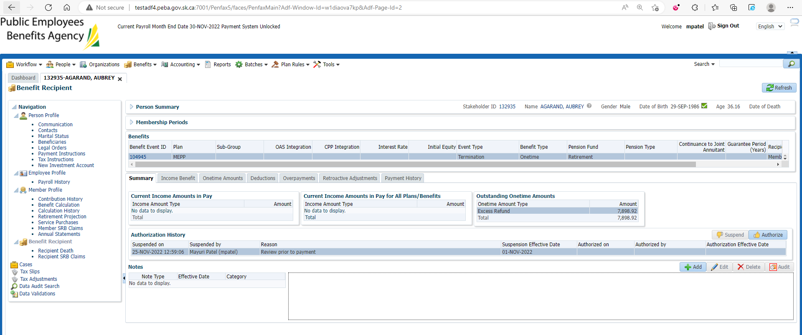

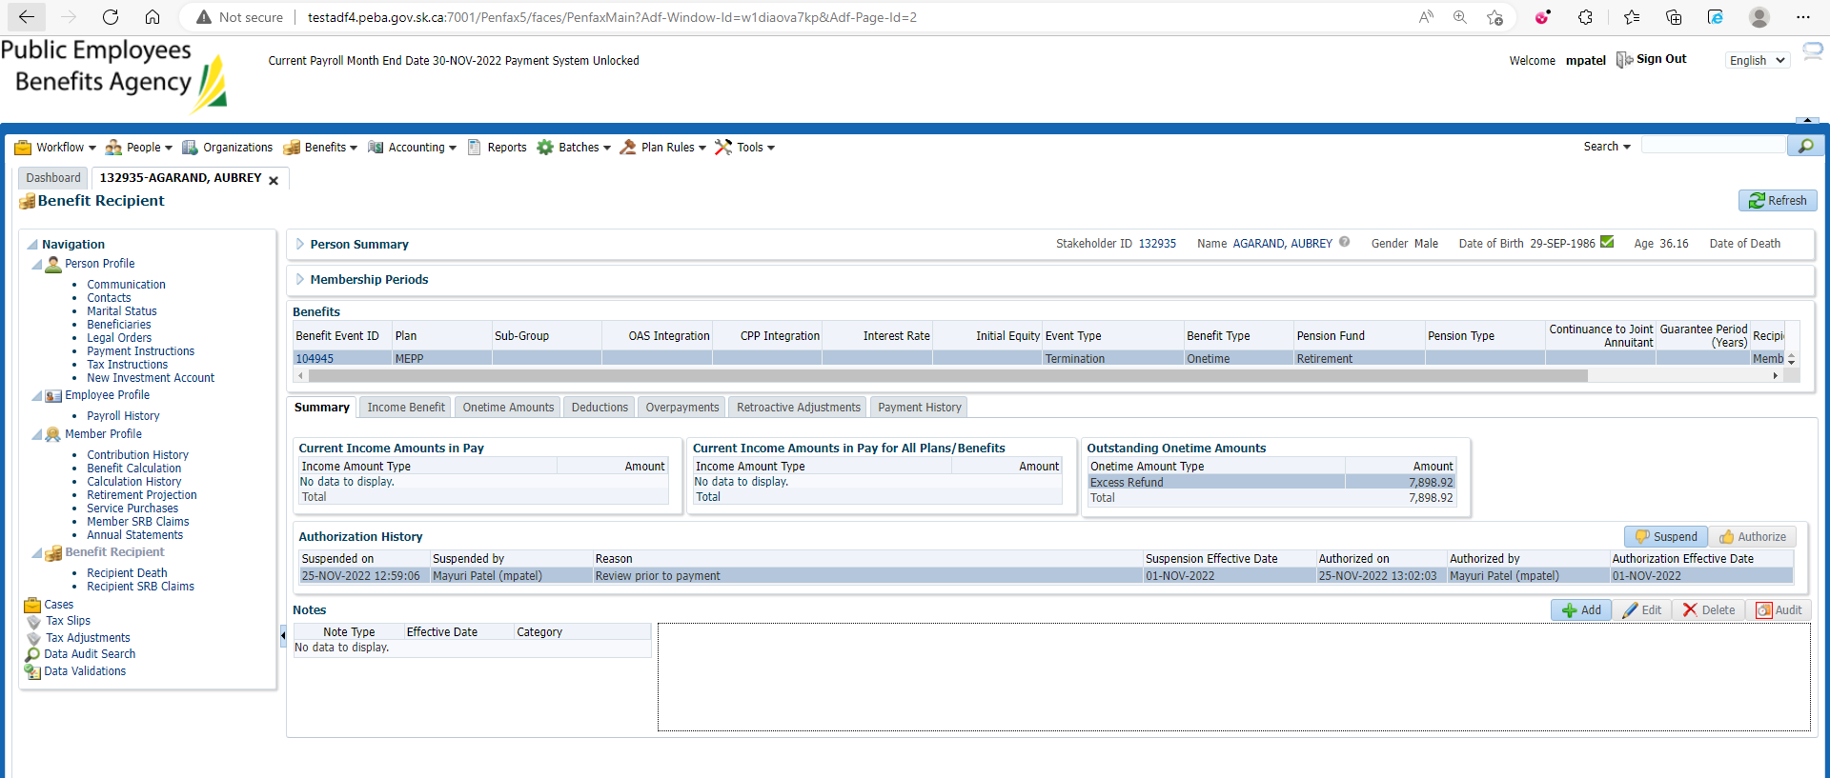

After Payment Batch

Payment has Paid out

